PROJECT DESIGN PHASE-1

**Real Time River Water Quality Monitoring and Control System**

**Team Leader: Team Member:**

Gokula Lakshmi APavithra G A

Varsha R

Ajay R

**PROBLEM STATEMENT**

Due to the limited water resources and the endangerment of pollution , water becomes the immense need of the world. The advancement in the modern life style is also one of the reason to the emerging danger of the water borne diseases and water scarcity. Thus in order to get rid of diseases and to increase the availability of water we need to monitor the quality as well to implement a control system. Using the components of wireless sensors network with the help of IOT a solution is to be proposed for “ water Quality monitoring system” that checks all the quality parameter and provide better performance rate with perfect accuracy.

**IDEA /SOLUTIONS**

Due to the limitation of the budget, the current projects only focuses mainly on measuring the quality of river water parameters. This project can be extended into an efficient water management system of a local area. Hence our idea is to focus on the parameters such as accuracy of PH sensor as the program encoded should be highly reliable **.**Proper purification process using Water quality index since the usage of sensors detect different parameters of the water but fails in purification process of water.

**Novelty**

Most of the Projects are done only based on the detection of Parameters, but we are Calculating the **Water quality** **Index.**

**The Value of the Sensors are Shown as follows**

|  |  |
| --- | --- |
| Safe water | Unsafe Water |
| pH | 6.5-8.5 | <6.49 and>8.5 |
| Turbidity | <5 | >5 |
| Action | Turn On Green Led | Turn On Red Led and Buzzer |

Threshold values of temperature sensor

|  |  |  |
| --- | --- | --- |
| Normal | Hot | Cold |
| Temperture | 10<=T>=29 | T>29 | T<10 |
| Action | Green Led | Red Led | Blue Led |

The above tabulation shows the value of the sensors , When the Value Exceeds, Led or Buzzer is used as a indication.

**CUSTOMER SATISFACTION**

Our ultimate Customer is **Government .** The aim of our water quality monitoring system is to meet the demand qualitatively and quantitatively. Although quality can be maintained with appropriate operation and maintenance strategies, supplying increasing demand in terms of quantity is a problem, because large-scale investments are sought for water supply utilities. However, satisfaction of consumer cannot be neglected under these circumstances. Hence the objective of the current study is to examine the influence of the level of service supplied, water quality variations and the geographical location of consumers on their perceptions on service delivery, satisfaction and risk perception.

**Business Model**

Our System Will be more beneficial to the Government since Government is our Supreme Customer . We Will Showcase our System to the Government. As the Whole process is controlled by sensor and other components Manpower can be very much reduced. So the government can save Labour cost and can gain more profit. As the sensors are monitoring some of the parameters of water ,the error can be reduced.

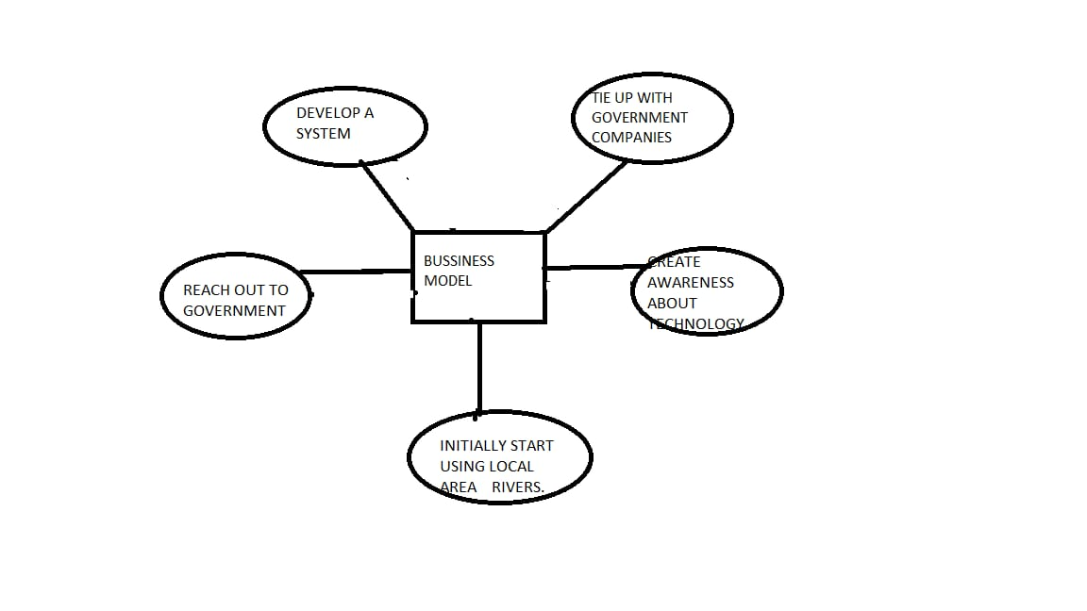

**Scalability of Solution**

Our Project is very much efficient since it is based on IOT. We are using Temperature Sensor, Humidity Sensor , Flow Sensor , Flow of the Water . As the Parameters of the water are being monitored continuously , the quality of water can be measured easily which makes the system more efficient , Since we are Calculating the index of water , the system will become more efficient .